* Get to Bed Early
* Get to School on time
* Eat a good, healthy breakfast
* Be ready to Show What You Know!

**Coming Up**

Reading

This week we are focusing on vocabulary.

Math

Data and Graphs will be explored this week.

Science

We are still learning about weather and climate. Ask your child what type of clouds he or she sees outside.

Social Studies

We are learning about government

I would like to wish all the mothers a very Happy Mother’s Day on Sunday. You deserve to have an awesome day! Enjoy!!!

**Dates to**

**Remember**

Tuesday, May 8th……

M-Step ELA at 8:30 am

Wednesday, May 9th……

M-Step Make-up

Thursday, May 10th……

M-Step Math at 8:30

Friday, May 11th….

M-Step Make-ups

May 7, 2018

**M-Step Tips**

**Ms. Papa’s Page**

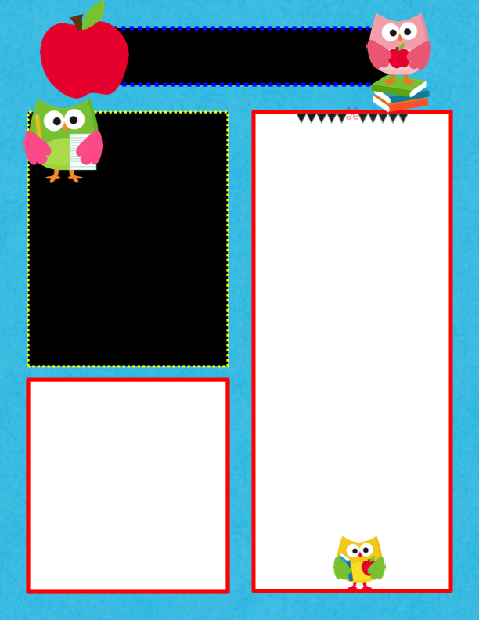

WOULD YOU LIKE ONE OR TWO COLUMNS?

If you would like two columns, delete this text box. There are two columns underneath!

TIP: When printing these newsletters, select “scale to fit” in the printing options.

**Add a Picture or Text Here**

NOTE: To change any of the pictures in this template, Right click on the picture. Select “Change Picture.” (Mac Users: Hold down the control key and click.)

Homework to Expect

This Week

Monday: blah, blah, blah, blah, blah, blah, blah, blah, blah, blah

Tuesday: blah, blah, blah, blah, blah, blah, blah, blah, blah, blah

Wednesday: blah, blah, blah, blah, blah, blah, blah, blah, blah, blah

Thursday: blah, blah, blah, blah, blah, blah, blah, blah, blah, blah

Want to Add a Picture Instead of Text?

Click on a text box. Go to the insert menu above and insert a picture! ☺

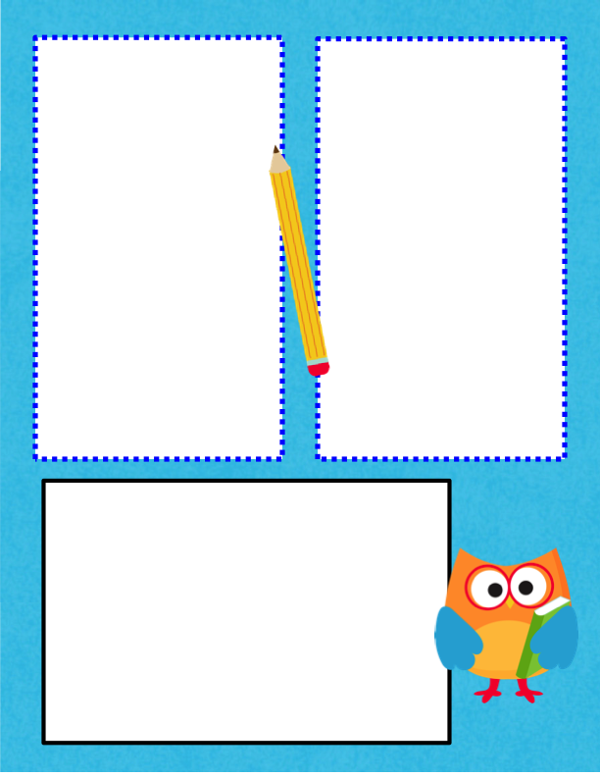

This week has been a hoot!

Enter caption here.

If you desire to add more text instead of a picture, delete the above picture and pull this text box up.

Enter caption here.

If you desire to add more text instead of a picture, delete the above picture and pull this text box up.



Right click on the above picture. Select “Change Picture.” (If on a Mac, hold down the control key and click.)

